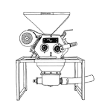
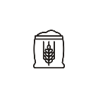

THE BREWING PROCESS
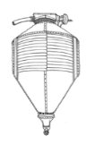
- THE MILL: The malt kernels are cracked in the roller mill to expose the starchy endosperm while preserving the husks.
- GRIST CASE: The Grist Case is a hopper mounted on load cells used to precisely weigh the required malt.
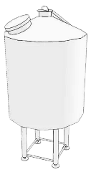
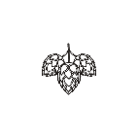


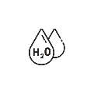
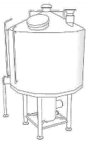
- MASH TUN: Cracked malt and water are mixed at a specific ratio and temperature. This mashing process uses natural enzymes to convert malt starch to fermentable sugars.

- BREW KETTLE: The sugar created in the mash tun is drawn off to the Brew Kettle in a liquid form called wort. It is in the Brew Kettle that hops are introduced for bitterness and flavor.
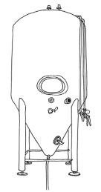
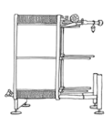
- PLATE & FRAME HEAT EXCHANGER: The sweet, hopped wort is cooled from boiling to fermentation temp generating hot water for subsequent use.

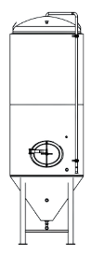
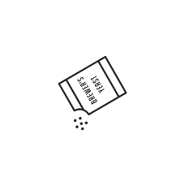
- FERMENTOR: Yeast is added to the cooled wort in the Fermentor. The yeast consumes the sugars in the sweet wort to produce alcohol and CO2.
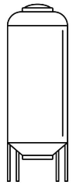
- CONDITIONING TANK: After fermentation is complete, the beer is transferred to a conditioning tank. Aging allows for by-products of fermentation to mellow and beer clarification to naturally occur.
- SERVING TANK: The finished beer is moved to 15 bbl serving tanks, carbonated, and dispensed directly.
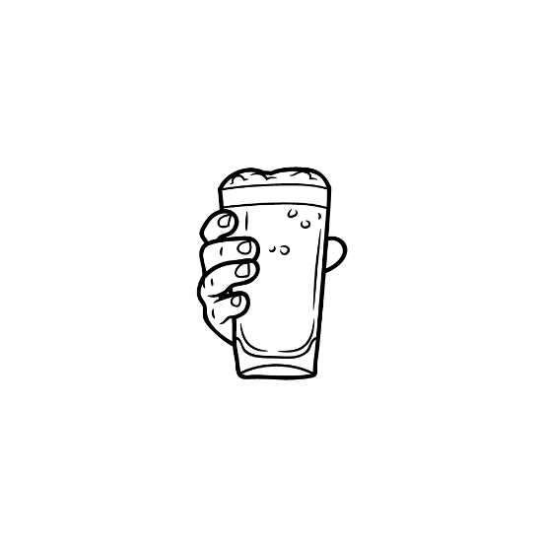
- YOUR GLASS: The most important vessel in the brewing process. It is here that the culmination of all our efforts can be tasted and judged. Cheers!
Head Brewer, Drew Weber
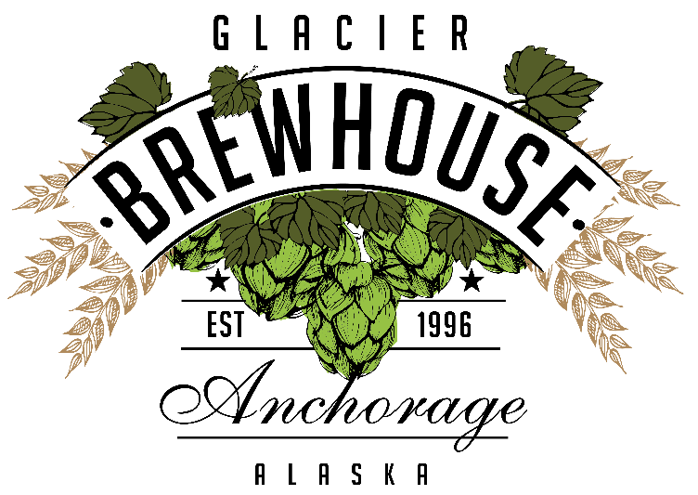
ALASKA’S CRAFT BREWERY
GLACIER BREWHOUSE is a Brewpub – A combination of a restaurant and a brewery. Our Brewery brews our seven flagship beers and many seasonal, rotating beers, including a cask-conditioned selection. We specialize in oak aging beers in our magnificent “Wall of Wood”. We use Hungarian, Ukrainian, and French oaks, virgin oaks and oaks previously used in making bourbon, whiskey, and wine. Tours available upon request!
BEER TO GO
½ GALLON GROWLERS (64OZ)
- CRAFT BEERS ARE $8.50 - $9.50 + JUG FEE.
- HIGH GRAVITY BEERS ARE $13.95 - $21.95 + JUG FEE.
The Jug Fee is $7.00 and non-refundable. Trade your previous growler in for another beer to have the fee waived. *Cask conditioned and other small batch beers are not available in growlers.

*GROWLER TUESDAYS*
Specially priced growlers.
*Does not include Jug Fee.
$6.00-$9.00 Growlers of our Craft Beers.
$9.00-$11.00 growlers of our Specialty Beers.
$15.00-$19.00 growlers for our select High Gravity Beers.

KEGS TO GO
5-Gallon Keg of BrewHouse Beer.
907-792-3772
We can also fill personal kegs!
Call the Brewery or ask your server today.
$48 for a 5-gallon keg of soda or
$119 for a 15.5-gallon keg of soda

Blonde Pint 7.50
Crisp and refreshing. Our Blonde Ale has a light straw color. The malt body is light and complimented by a mild cascade hop aroma and a smooth creamy finish. Premium two row barley from the Pacific Northwest lets this beer shine.
Alcohol: 4.76% by volume. BU’s 15

Amber Pint 7.50
Malty, medium bodied, and balanced out with hints of chocolate and caramel from the crystal malt, Munich malt, and roast malt. Cascade hops complement the malt sweetness perfectly.
Alcohol: 5.67% by volume. BU’s 25

India Pale Ale Pint 7.50
This is our green giant. If you like hop aroma, flavor, and a clean, crisp, balanced bitterness, you will love this beer. Our special double dry hopping regiment takes place in the aging tank as well as the serving tank. Simcoe and Amarillo hops render big floral and citrus aromas. English and floor malted barley provides the backbone necessary to round out this fruity, unfiltered, session-like IPA.
Alcohol: 6.35% by volume. BU’s 55

Bavarian Hefeweizen Hefe 7.50
This Bavarian style unfiltered wheat beer boasts huge fruity aromas of banana and clove. Made in a traditional style with premium German pilsner malt and German Tettnang hops. Low bitterness, refreshing, and smooth. We serve it without a lemon unless the guest requests one.
Alcohol: 5.00% by volume. BU’s 17

Oatmeal Stout Mug 7.50
A full bodied opaque black ale with flavors chocolate and roast. Premium pale malt from the Pacific Northwest provides the base while dark malts and crystal malts combine with the rolled oats to give you a luscious velvet mouthfeel. U.S. Perle hops are used. Nitrogenated.
Alcohol: 5.61% by volume. BU’s 21

Raspberry Wheat Hefe 7.50
An unfiltered wheat beer loaded with 210 pounds of real red raspberries. Tart and satiating, this beer is red in color and boasts fruity flavors of – what else – red raspberries. Low bitterness, refreshing and smooth.
Alcohol: 4.76% by volume. BU’s 21

Imperial Blonde Snifter 8.50
High alcohol, slightly malty, creamy, and smooth. A half pound of honey per gallon is used to attain the high yet seductive alcohol level. The Denali climbers in Talkeetna call this beer the Ice Axe Ale.
Alcohol: 9.00% by volume. BU’s 24

Cask Conditioned Ale Prices May Vary
Served in the traditional English style from a beer engine and served at 52 F. Ask your server about today’s selection.
Beer Flights

Flagship 9.95
Blonde, Amber, IPA, Bavarian Hefeweizen, Oatmeal Stout

IPA Flight 12.95
Hazy, IPA, Rye, Pomegranate, DIPA
Sip into Spring 12.95
Key Lime Wheat, Raspberry Wheat, Razz XXX, Cask IPA, Spicy Mango IPA

NA - IPA – Non-Alcoholic Beer Pint 7.50
Alcohol: 0.32% by volume. BU’s 30
Spicy Mango IPA Pint 7.95
Buckle up! This ale is brewed with the infamous Ghost Pepper Chili! Explosively juicy mango and sweet malt balance out the fire from this glass of sunshine. It’s fermented to bring out hop characteristics you may be surprised by and aged on hops like a classic West Coast IPA.
Alcohol: 6.3% by volume. BUs: 25
Rye IPA Pint 7.95
This IPA has a backbone of spicy rye malt to add depth and texture combined with bright American hops for waves of citrus and pine. Rich and tastefully bitter with a crisp, dry, warming finish.
Alcohol: 7.2% by volume. BUs: 60
FAIR-ly Hazy Dayz IPA Pint 7.95
Aromas of Valencia orange and lemon verbena leap out of this hazy IPA with a generous amount of malted oats lending a pillowy and silky mouth feel. Double dry-hopped with over two pounds per barrel of Simcoe, Mosaic, and Citra.
Alcohol: 7.07% by volume. BU’s 5
Pomegranate IPA Snifter 8.50
This high gravity IPA delivers a vivid burst of natural tartness from real pomegranate and Citra hops. Brightly aromatic with notes of grapefruit, lime, and tropical fruit. Crisp and hop-forward. No Extracts. No Shortcuts. Just good beer done right.
Alcohol: 9.0% by volume. BUs: 50
BrewHouse DIPA Snifter 7.95
Over twice the amount of hops are used in this beer as compared to our standard IPA. This is a citrusy, floral, hop-head’s delight for sure!
Alcohol: 8.3% by volume. BUs: 140
Key Lime Wheat Hefe 7.95
This sweet and tart beer is a blast of summer. Made by using a combination of German Pilsner and Wheat malt along with a large amount of key lime puree brings a sunburst of flavor.
Alcohol: 5.0% by volume. BU’s 17
Razz XXX Snifter 10.95
This festive wheat ale is loaded with bright, juicy raspberries that pop against a smooth, slightly sweet wheat backbone. It pours a cheerful berry-red and finishes clean, with just a hint of tartness that keeps you coming back for another sip.
Alcohol: 9.00% by volume. BU’s: 24
Imperial Milk Stout Snifter 8.50
This rich Imperial Milk Stout is smooth, dark, and warming. Oats create a velvety body while lactose adds a touch of creamy sweetness. Dark chocolate, roasted coffee, and cocoa with a smooth, full finish.
Alcohol: 10.2% by volume. BU’s 21
*2025 Peerless Barrel Russian Imperial Stout Snifter 10.95
Bold, sweet, and decadent with notes of rich malt, dark chocolate, vanilla, coconut, and roasted grains. Aged in Peerless Bourbon Casks.
Alcohol: 10.5% by volume. BU’s 50
*2022 Oak Aged Eisbock Snifter 10.95
Ruby red in color, this Eisbock picked up complex notes of vanilla and coconut after being aged in Hotel Tango oak barrels.
Alcohol: 10% by volume. BU’s 26
*2025 Peerless Barrel Aged Big Woody Barleywine Snifter 10.95
Flavors of sweet malt, bourbon, vanilla and caramel balance this beer perfectly. No expense was spared with the use of English floor malt.
Alcohol: 10.5% by volume. BU’s 80
22oz SPECIALTY BOTTLES:
$23 – For Here $18 – To Go
2025 Peerless Bourbon Aged Eisbock
2025 Peerless Russian Imperial Stout
2025 Peerless Barrel Aged Big Woody Barleywine

