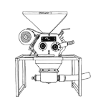
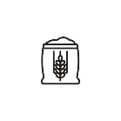

THE BREWING PROCESS
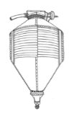
- THE MILL: The malt kernels are cracked in the roller mill to expose the starchy endosperm while preserving the husks.
- GRIST CASE: The Grist Case is a hopper mounted on load cells used to precisely weigh the required malt.
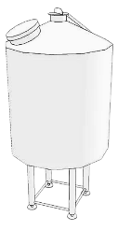
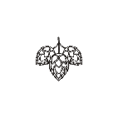


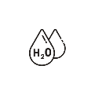
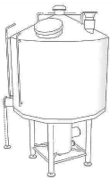
- MASH TUN: Cracked malt and water are mixed at a specific ratio and temperature. This mashing process uses natural enzymes to convert malt starch to fermentable sugars.

- BREW KETTLE: The sugar created in the mash tun is drawn off to the Brew Kettle in a liquid form called wort. It is in the Brew Kettle that hops are introduced for bitterness and flavor.
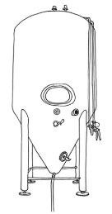
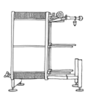
- PLATE & FRAME HEAT EXCHANGER: The sweet, hopped wort is cooled from boiling to fermentation temp generating hot water for subsequent use.

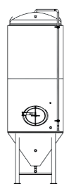
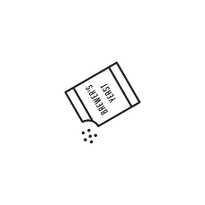
- FERMENTOR: Yeast is added to the cooled wort in the Fermentor. The yeast consumes the sugars in the sweet wort to produce alcohol and CO2.
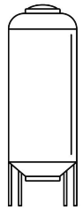
- CONDITIONING TANK: After fermentation is complete, the beer is transferred to a conditioning tank. Aging allows for by-products of fermentation to mellow and beer clarification to naturally occur.
- SERVING TANK: The finished beer is moved to 15 bbl serving tanks, carbonated, and dispensed directly.
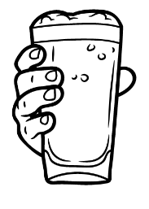
- YOUR GLASS: The most important vessel in the brewing process. It is here that the culmination of all our efforts can be tasted and judged. Cheers!
Head Brewer, Drew Weber
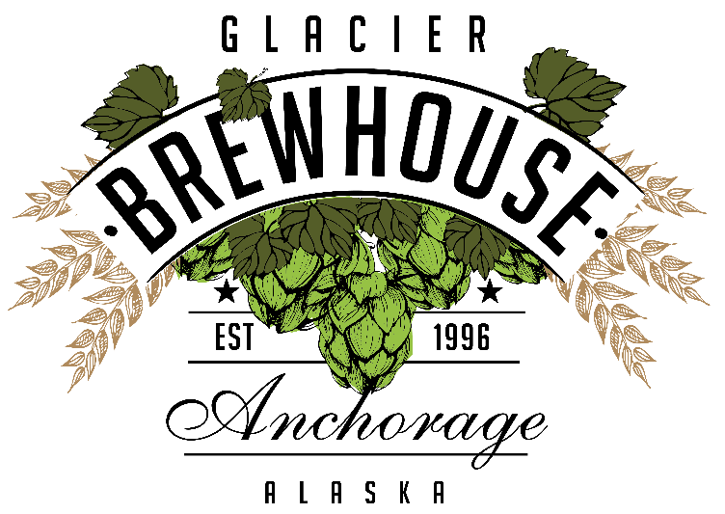
ALASKA’S CRAFT BREWERY
GLACIER BREWHOUSE is a Brewpub – A combination of a restaurant and a brewery. Our Brewery brews our seven flagship beers and many seasonal, rotating beers, including a cask-conditioned selection. We specialize in oak aging beers in our magnificent “Wall of Wood”. We use Hungarian, Ukrainian, and French oaks, virgin oaks and oaks previously used in making bourbon, whiskey, and wine. Tours available upon request!
BEER TO GO
½ GALLON GROWLERS (64OZ)
- CRAFT BEERS ARE $8.50 - $9.50 + JUG FEE.
- HIGH GRAVITY BEERS ARE $13.95 - $21.95 + JUG FEE.
The Jug Fee is $7.00 and non-refundable. Trade your previous growler in for another beer to have the fee waived. *Cask conditioned and other small batch beers are not available in growlers.

*GROWLER TUESDAYS*
Specially priced growlers.
*Does not include Jug Fee.
$6.00-$9.00 Growlers of our Craft Beers.
$9.00-$11.00 growlers of our Specialty Beers.
$15.00-$19.00 growlers for our select High Gravity Beers.

KEGS TO GO
5-Gallon Keg of BrewHouse Beer.
907-792-3772
We can also fill personal kegs!
Call the Brewery or ask your server today.
$48 for a 5-gallon keg of soda or
$119 for a 15.5-gallon keg of soda

Blonde Pint 7.50
Crisp and refreshing. Our Blonde Ale has a light straw color. The malt body is light and complimented by a mild cascade hop aroma and a smooth creamy finish. Premium two row barley from the Pacific Northwest lets this beer shine.
Alcohol: 4.76% by volume. BU’s 15

Amber Pint 7.50
Malty, medium bodied, and balanced out with hints of chocolate and caramel from the crystal malt, Munich malt, and roast malt. Cascade hops complement the malt sweetness perfectly.
Alcohol: 5.67% by volume. BU’s 25

India Pale Ale Pint 7.50
This is our green giant. If you like hop aroma, flavor, and a clean, crisp, balanced bitterness, you will love this beer. Our special double dry hopping regiment takes place in the aging tank as well as the serving tank. Simcoe and Amarillo hops render big floral and citrus aromas. English and floor malted barley provides the backbone necessary to round out this fruity, unfiltered, session-like IPA.
Alcohol: 6.35% by volume. BU’s 55

Bavarian Hefeweizen Hefe 7.50
This Bavarian style unfiltered wheat beer boasts huge fruity aromas of banana and clove. Made in a traditional style with premium German pilsner malt and German Tettnang hops. Low bitterness, refreshing, and smooth. We serve it without a lemon unless the guest requests one.
Alcohol: 5.00% by volume. BU’s 17

Oatmeal Stout Mug 7.50
A full bodied opaque black ale with flavors chocolate and roast. Premium pale malt from the Pacific Northwest provides the base while dark malts and crystal malts combine with the rolled oats to give you a luscious velvet mouthfeel. U.S. Perle hops are used. Nitrogenated.
Alcohol: 5.61% by volume. BU’s 21

Raspberry Wheat Hefe 7.50
An unfiltered wheat beer loaded with 210 pounds of real red raspberries. Tart and satiating, this beer is red in color and boasts fruity flavors of – what else – red raspberries. Low bitterness, refreshing and smooth.
Alcohol: 4.76% by volume. BU’s 21

Imperial Blonde Snifter 8.50
High alcohol, slightly malty, creamy, and smooth. A half pound of honey per gallon is used to attain the high yet seductive alcohol level. The Denali climbers in Talkeetna call this beer the Ice Axe Ale.
Alcohol: 9.00% by volume. BU’s 24

BrewHouse DIPA Snifter 7.95
Over twice the amount of hops are used in this beer as compared to our standard IPA. This is a citrusy, floral, hop-head’s delight for sure!
Alcohol: 8.3% by volume. BUs: 140

Cask Conditioned Ale Prices May Vary
Served in the traditional English style from a beer engine and served at 52 F. Ask your server about today’s selection.

Beer Flights

Flagship 9.95
Blonde, Amber, IPA, Bavarian Hefeweizen, Oatmeal Stout

NA - IPA – Non-Alcoholic Beer Pint 7.50
Alcohol: 0.32% by volume. BU’s 30

FAIR-ly Hazy Dayz IPA Pint 7.95
Aromas of Valencia orange and lemon verbena leap out of this hazy IPA with a generous amount of malted oats lending a pillowy and silky mouth feel. Double dry-hopped with over two pounds per barrel of Simcoe, Mosaic, and Citra.
Alcohol: 7.07% by volume. BU’s 50

Pilsner Hefe 7.95
Brewed with premium German malt, Czech Saaz hops and German yeast, this Pilsner was lagered for a month at near-freezing temperatures before being filtered. Bready mal flavor and floral hop aroma make this crisp, clean beer a perfect summer companion.
Alcohol: 5.2% by volume. BU’s 25

Porter Mug 7.95
Deep, dark and chocolishous flavors abound. With medium body, low bitterness and velvet mouth feel, this black beauty is sure to please.
Alcohol: 5.1% by volume. BU’s 20

Imperial Guava Wheat Snifter 8.50
This tropical vacation in a glass packs a punch while remaining smooth and incredibly refreshing. It busts with lush tropical pink guava aromas that perfectly balance he soft pillowy mouthfeel of a classic wheat beer.
Alcohol: 9.9% by volume. BU’s 14

Belgian Strong Snifter 10.95
Brewed to honor 30 years of The Glacier BrewHouse in the heart of Anchorage. This Belgian Strong Ale is a celebration of craftmanship, resilience, and community. Pouring deep ruby-amber with garnet highlights, it opens with inviting aromas of dark fruit, caramel, and gentle spice. Complex yet approachable, this beer is meant to be savored raising a glass to three decades of brewing.
Alcohol: 10.4% by volume. BU’s 20

Oak Aged Belgian Strong Snifter 10.95
To mark three decades of brewing at The Glacier BrewHouse, this Belgian Strong was aged in Jim Beam bourbon barrels, allowing oak and time to shape it character. Deep mahogany-amber in the glass, it opens with aromas of dark cherry, brown sugar and vanilla, accented by hints of toasted oak and bourbon spice. Bold yet refined, this beer celebrates tradition, patience and 30 years of brewing at the edge of Alaska’s frontier.
Alcohol: 10.4% by volume. BUs: 20

*2025 Peerless Barrel Big Woody Barleywine Snifter 10.95
Flavors of sweet malt, bourbon, vanilla and caramel balance this beer perfectly. No expense was spared with the use of English floor malt.
Alcohol: 10.5% by volume. BU’s 80

22oz SPECIALTY BOTTLES:
$23 – For Here $18 – To Go
Belgian Strong
2025 Peerless Russian Imperial Stout
2025 Peerless Barrel Aged Big Woody Barleywine
Peerless Eisbock

